BASICS OF MANAGEMENT & ENTREPRENEURSHIP DEVELOPMENT

SEMSETER :5TH BRACNCH: INFORMATION TECHNOLOGY

CHAPTER 1

TOPIC 1.1 DEFINITIONS OF MANAGEMENT

According to Peter Drucker
"Management is a multi-purpose organ that manages business and manages managers and manages workers and work."
This definition of management was given by Peter Drucker in his book "The Principles of Management".

According to Mary Parker Follet,
"Management is the art of getting things done through people."

According to Harold Koontz,
"Management is the art of getting things done through and with people in formally organized groups."
Harold Koontz gave this definition of management in his book "The Management Theory Jungle".

According to Henri Fayol,
"To manage is to forecast and to plan, to organize, to command, to co-ordinate and to control."
Henri Fayol gave this definition of management in his book "Industrial and General Administration".

TOPIC 1.2 & 1.3

Concept of Management:
One way to analyze management is to think in terms of what a manager does. Using this approach, we can arrive at the management process which describes the work of any manager.

VARIOUS FUNCTIONS OF MANAGEMENT
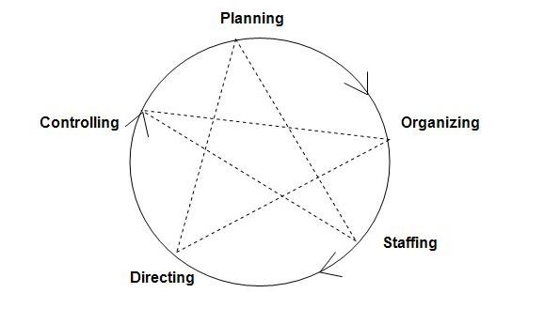
Planning
It is the basic function of management. It deals with chalking out a future course of action & deciding in advance the most appropriate course of actions for achievement of pre-determined goals. According to KOONTZ, “Planning is deciding in advance - what to do, when to do & how to do. It bridges the gap from where we are & where we want to be”. A plan is a future course of actions. It is an exercise in problem solving & decision making. Planning is determination of courses of action to achieve desired goals. Thus, planning is a systematic thinking about ways & means for accomplishment of pre-determined goals. Planning is necessary to ensure proper utilization of human & non-human resources. It is all pervasive, it is an intellectual activity and it also helps in avoiding confusion, uncertainties, risks, wastages etc.

Organizing
It is the process of bringing together physical, financial and human resources and developing productive relationship amongst them for achievement of organizational goals. According to Henry Fayol, “To organize a business is to provide it with everything useful or its functioning i.e. raw material, tools, capital and personnel’s”. To organize a business involves determining & providing human and non-human resources to the organizational structure. Organizing as a process involves:

- Identification of activities.
- Classification of grouping of activities.
- Assignment of duties.
- Delegation of authority and creation of responsibility.
- Coordinating authority and responsibility relationships.
Staffing
It is the function of manning the organization structure and keeping it manned. Staffing has assumed greater importance in the recent years due to advancement of technology, increase in size of business, complexity of human behavior etc. The main purpose o staffing is to put right man on right job i.e. square pegs in square holes and round pegs in round holes. According to Kootz &O’Donell, “Managerial function of staffing involves manning the organization structure through proper and effective selection, appraisal & development of personnel to fill the roles designed un the structure”. Staffing involves:

- Manpower Planning (estimating man power in terms of searching, choose the person and giving the right place).
- Recruitment, Selection & Placement.
- Training & Development.
- Remuneration.
- Performance Appraisal.
- Promotions & Transfer.

Directing
It is that part of managerial function which actuates the organizational methods to work efficiently for achievement of organizational purposes. It is considered life-spark of the enterprise which sets it in motion the action of people because planning, organizing and staffing are the mere preparations for doing the work. Direction is that inert-personnel aspect of management which deals directly with influencing, guiding, supervising, motivating sub-ordinate for the achievement of organizational goals. Direction has following elements:

- Supervision
- Motivation
- Leadership
- Communication

- Supervision- implies overseeing the work of subordinates by their superiors. It is the act of watching & directing work & workers.

- Motivation- means inspiring, stimulating or encouraging the sub-ordinates with zeal to work. Positive, negative, monetary, non-monetary incentives may be used for this purpose.

- Leadership- may be defined as a process by which manager guides and influences the work of subordinates in desired direction.

- Communications- is the process of passing information, experience, opinion etc from one person to another. It is a bridge of understanding.

Controlling
It implies measurement of accomplishment against the standards and correction of deviation if any to ensure achievement of organizational goals. The purpose of controlling is to ensure that everything occurs in conformities with the standards. An efficient system of control helps to predict deviations before they actually occur. According to Theo Haimann, “Controlling is the process of checking whether or not proper progress is being made towards the objectives and goals and acting if necessary, to correct any deviation”. According to Koontz &O’Donell “Controlling is the measurement & correction of performance activities of subordinates in order to make sure that the enterprise objectives and plans desired to obtain them as being accomplished”. Therefore controlling has following steps:

- Establishment of standard performance.
- Measurement of actual performance.
- Comparison of actual performance with the standards and finding out deviation if any.
- Corrective action.

TOPIC 1.4
AREAS OF MANAGENET

1. Human resource management:
Human resource development or personnel management or manpower management is concerned with obtaining and maintaining of a satisfactory and satisfied work force i.e., employees. It is a specialized branch of management concerned with ‘man management’.
The recruitment, placement, induction, orientation, training, promotion, motivation, performance appraisal, wage and salary, retirement, transfer, merit-rating, industrial relations, working conditions, trade unions, safety and welfare schemes of employees are included in personnel management. The object of personnel management is to create and promote team spirit among workers and managers.

2. Production management:
Production management refers to planning, organization, direction, coordination and control of the production function in such a way that desired goods and services could be produced at the right time, in right quantity, and at the right cost. Some authors treat material, purchase and inventory management as part of production management. Production management involves the following functions:

(a) Product planning and development,

(b) Plant location, layout and maintenance,

(c) Production systems and machines,

(d) Management of purchase and storage of materials,

(e) Ensuring effective production control.

3. Office management:
Office management can be defined as, “the organization of an office in order to achieve a specified purpose and to make the best use of the personnel by using the most appropriate machines and equipment, the best possible methods of work and by providing the most suitable environment.”
The main topics of office management are: office accommodation, layout and environment, communication, handling correspondence and mail, typing and duplicating, record management and filing, indexing, forms and stationary, machines and equipments, O & M, office reporting, work measurement and office supervision.

4. Financial management:
Financial management can be looked upon as the study of relationship between the raising of funds and the deployment of funds. The subject matter of financial management is: capital budgeting cost of capital, portfolio management, dividend policy, short and long term sources of finance. Financial management involves mainly three decisions pertaining to:

1. Investment policies: It dictates the process associated with capital budgeting and expenditures. All proposals to spend money are ranked and investment decisions are taken whether to sanction money for these proposed ventures or not.
2. Methods of financing:
A proper mix of short and long term financing is ensured in order to provide necessary funds for proposed ventures at a minimum risk to the enterprise.

3. Dividend decisions:

This decision affects the amount paid to shareholders and distribution of additional shares of stock.

5. Marketing management:
Philip Kotler views marketing as a social and managerial process by which individuals and group obtain what they need and want through creating and exchanging products and values with others. American Marketing Association defines market­ing management as the “process of planning and executing the conception, pricing, promotion and distribution of ideas, goods and services to create exchange that satisfy individual and organizational objectives.”

The course content of marketing management generally includes: marketing concept, consumer behaviour, marketing mix, market segmentation, product and price decisions, promotion and physical distribution, marketing research and information, international marketing etc.

TOPIC 1.5 ORGANISATION STRUCTURE

Type # 1. Line Organisation:
Line organisation is the simplest and oldest form of organisation structure. It is called as military or departmental or scalar type of organization. Under this system, authority flows directly and vertically from the top of the managerial hierarchy ‘down to different levels of managers and subordinates and down to the operative level of workers.
Line organisation clearly identifies authority, responsibility and accountability at each level. The personnel in Line organization are directly involved in achieving the objectives of the organization.
The line organisation structure is given below:
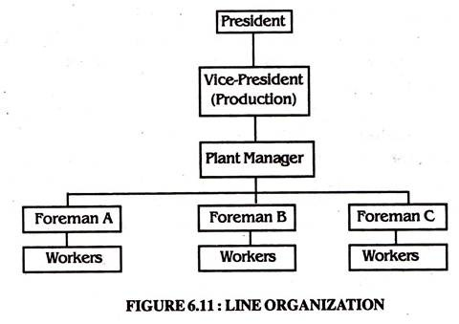
Advantages of Line Organization:
a. The line organization structure is very simple to understand and simple to operate.
b. Communication is fast and easy and feedback can be acted upon faster.
c. Responsibility is fixed and unified at each level and authority and accountability are clear-cut, hence each individual knows to whom he is responsible and who is or in truth responsible to him.
d. Since it is especially useful when the company is small in size, it provides for greater control and discipline in the organization.
e. It makes rapid decisions and effective coordination possible. So it is economic and effective.
f. The people in line type of organization get to know each other better and tend to feel close to each other.
g. The system is capable of adjusting itself to changing conditions for the simple reason that each executive has sole responsibility in his own sphere.
Disadvantages of Line Organization:
a. It is a rigid and inflexible form of organization.
b. There is a tendency for line authority to become dictatorial.
c. It overloads the executive with pressing activities so that long-range planning and policy formulation are often neglected.,
d. There is no provision for specialists and specialization, which is essential for growth and optimisation.
e. Different departments may be much interested in their self-interests, rather than overall organizational interests and welfare.
f. It is likely to encourage nepotism.
g. It does not provide any means by which a good worker may be rewarded and a bad one punished.

Type # 2. Functional Organisation:
The functional organisation was evolved by F.W. Taylor while he was working as a foreman. He suggested eight foremen, four in factory and four in planning division as under.
Factory Division:
(i) The gang boss,
(ii) The speed boss,
(iii) The inspector, and
(iv) The maintenance or repair boss.
Planning Division:
(i) Route Clerk,
(ii) Instruction card clerk,
(iii) Time and cost clerk, and
(iv) The shop disciplinarian.
He evolved his functional organisation system, which consists in “so dividing the work of management that each man, from the assistant superintendent down, shall have as few functions as possible to perform.”
According to Terry, “Functional organisation refers to the organisation which is divided into a number of functions such as finance, production, sales, personnel, office and research and development and each of functions are performed by an expert”. Line authority, staff authority and functional authority as a third type of authority are in this type of organisation.
Features of Functional Organisation:
a. Each worker receives instructions not only from one superior, but also from a group of specialists.
b. Three types of authority relationships are in the functional organisation such as line authority, staff authority and functional authority.
c. Staff specialists are given the authority to decide and do things in a limited way.
d. The scope of the work is kept limited but the area of authority is left unlimited.
e. There is a grouping of activities of the enterprise into certain major functional departments.
Advantages of Functional Organisation:
a. Each manager is an expert in his field. He has to perform a limited number of functions. So complete specialisation will be in functional organisation.
b. The greater degree of specialisation leads the improvement in the quality of product.
c. Since the job requirements are definite and tangible, organisation can achieve the intensive utilisation of the principle of specialisation of labour at the managerial level.
d. Specialisation will lead for mass production and standardisation.
e. Since experts get sufficient time for creative thinking, planning and supervision are made efficient.
f. It increases the work satisfaction for specialists who presumably do what they like to do.
Disadvantages of Functional Organisation:
a. Since there is no direct boss or controller of the workers, co-ordination is hard to achieve.
b. Since workers are under different bosses, discipline is hard to achieve. As results there will be low morale on the part of the workers.
c. The non-supervisory employees are uncertain as to whom they should turn for advice and aid when problem call for analysis.
d. Due to that control is divided, action cannot be taken immediately.
e. Since there will be many foreman of equal rank in the same department, the conflicts of leadership may arise.
f. It reduces the opportunities for the training of all-round executives to assume further leadership in the firm.

Type # 3. Matrix Organisation:
According to Stanley Davis and Paul Lawrence matrix organisation is “any organisation that employs a multiple command system that includes not only the multiple command structure, but also related support mechanism and an associated organisational culture and behaviour pattern.”
A matrix organisation, also referred to as the “multiple command system” has two chains of command. One chain of command is functional in which the flow of authority is vertical.
The second chain is horizontal depicted by a project team, which is led by the project, or group manager who is an expert in his team’s assigned area of specialisation.
Since the matrix structure integrates the efforts of functional and project authority, the vertical and horizontal lines of authority are combination of the authority flows both down and across. The matrix form of organisation is given below.
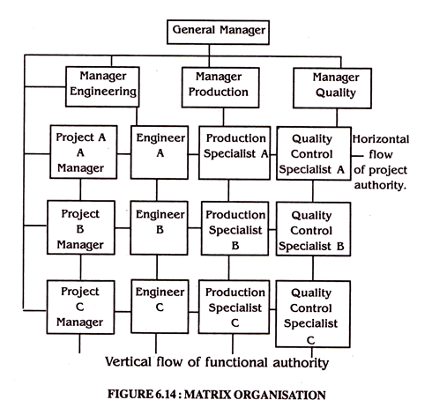
Advantages of Matrix Organisation:
1. Since there is both vertical and horizontal communication it increases the coordination and this coordination leads to greater and more effective control over operations.
2. Since the matrix organisation is handling a number of projects, available resources will be used fully.
3. It focuses the organisational resources on the specified projects, thus enabling better planning and control.
4. It is highly flexible as regards adherence to rules, procedures etc. Here experience is the best guide to establishing rules and procedures.
5. As any department or division has to harness its effort towards accomplishment of a single project, employees are effectively motivated.
Disadvantages of Matrix Organisation:
1. Since, there is more than one supervisor for each worker, it causes confusion and conflicts and reduce effective control.
2. There is continuous communication both vertically as well horizontally, which increases paper work and costs.
3. It is difficult to achieve a balance below on the projects technical and administrative aspects.

